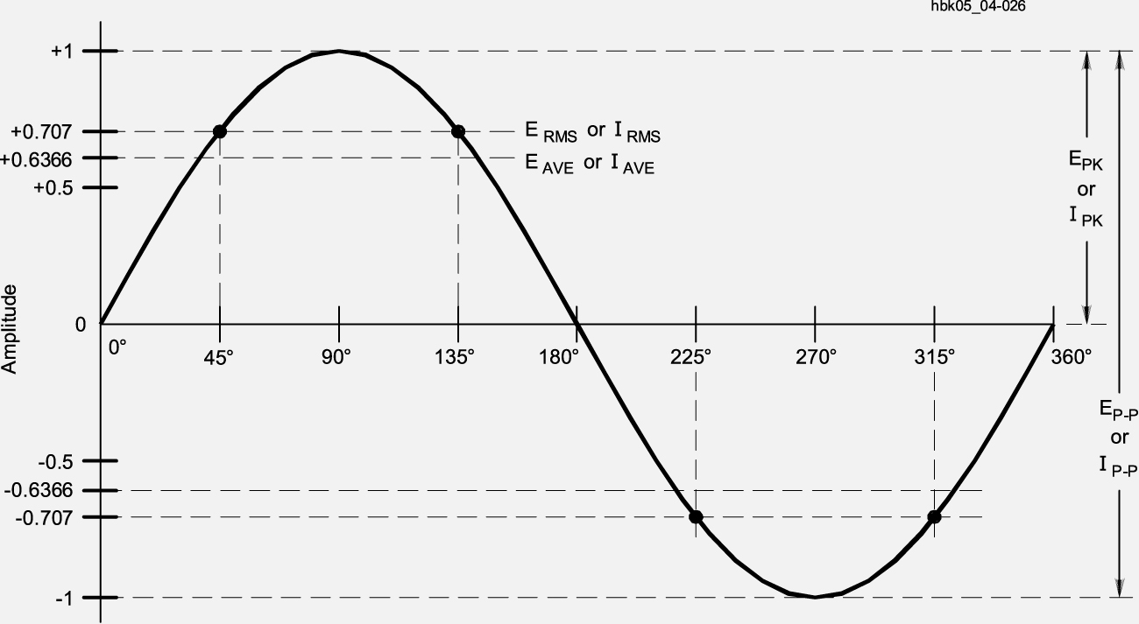

RMS voltage value is 0.707 times the ac waveform’s peak voltage

